**Leaflet Displays:**

1. **Main Map –** 
   1. **Basemap** 
      1. **Basemap only arabic, only english,**
2. Swipe 1994-2020
3. Time-lapse –
4. **Show case – bookmarks** 
   1. **One page with 3-6 maps bookmarked**

**Task JS:**

1. Polygons (Area A and Area B) don’t need labels and need to be 30% transparent
2. Points need labels ESPECIALLY Area_B – most important.
3. Toggle clustering on/off
4. Responsive – boxes should be responsive
5. Solution for photos in the labels – what are we going to do about this?
6. Test Arabic in pop up
7. Symbology for polygons based on the design
8. Search –

Most important:

Link photos to the points in the map

**Development Steps:**

**Process:**

GIS DATA: SHP -> MySQL -> SERVICE

|

**JAVA SPRING API**

|

Website (JS): **Leaflet** [ Mapbox or Google Maps]

**Stack:**

vue.js - leaflet - strapi

**wireframes for inspiration:**

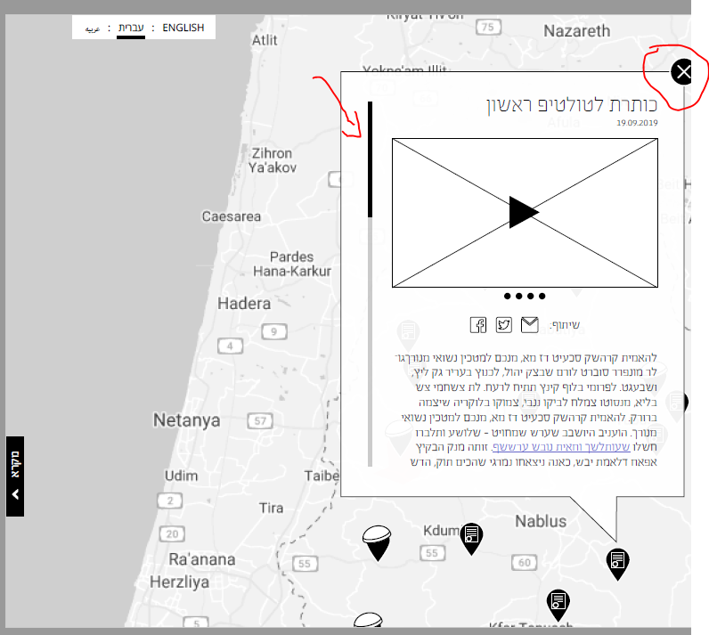

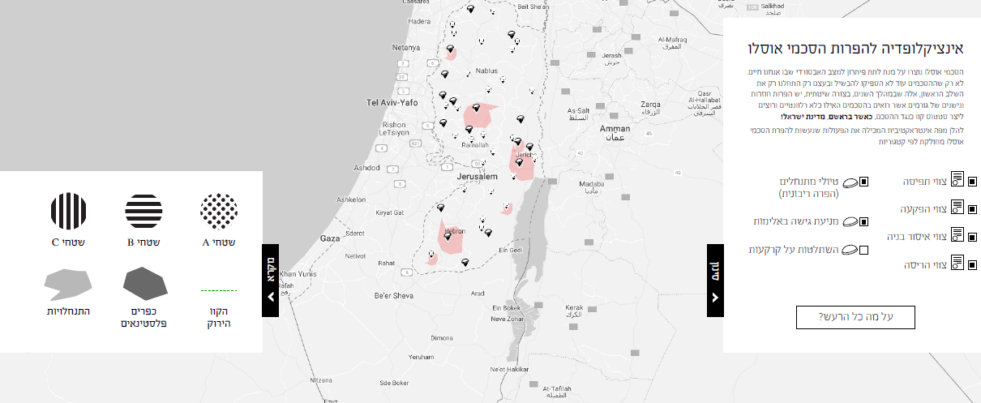

**Requirements:**

1. Sustainability! Need to have a process to swap and update data. Nothing should or can be static!
2. Map frames will be integrated into wordpress site managed by a client.
3. Map server must have full language support for Arabic, English and Hebrew.
4. Management Console tools for managing the map
5. A main map page with the desired GIS layers (tiled and responsive) with the following elements:
   1. Legend
   2. Layers which can be turned on and off by the user
   3. Background on/off
6. Then and Now: 1995 versus 2020 swipe map. We need to try to find a base map circa 1995 and one for 2020.

**General capabilities that can be applied on all maps:**

* Clustering / heatmap capabilities to reduce map clutter
* Each map feature will have the ability to have a pop-up which will return a window with pictures / video, data graph and a description as described in the wireframe document.
* Geofencing – will be able to control the extent of each map to help user focus on the desired area.
* Swipe maps as: 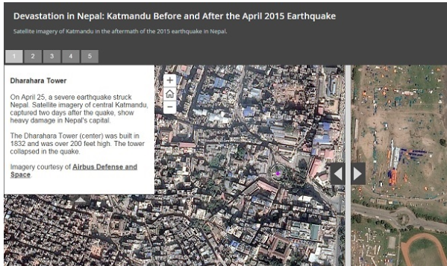
* Time enabled maps – display data on a map on a time line. For example, we can choose to display violations over time.

Transfer ownership plan: